**Please number each question and start each question on a new page.**

1. **(a) 011001001**
2. **(b) C9**

**2.**

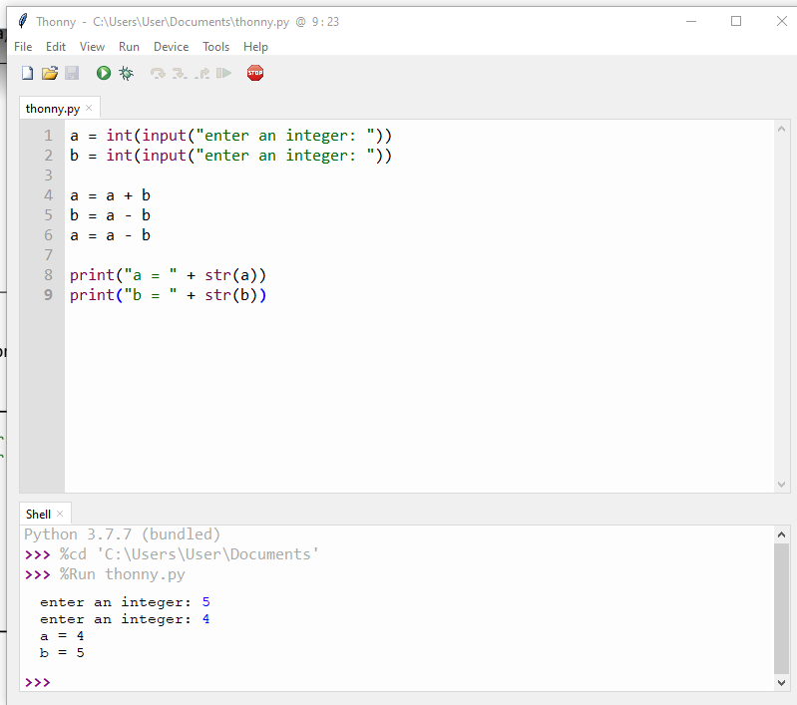

**To assign a and b their own integers**

1. **Stuck :(**

**4.**

**5.**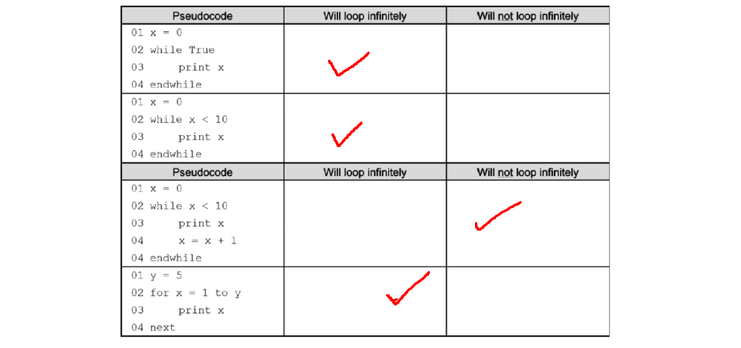

**6.** An algorithm is a set of rules or sequences that are used to solve problems and do calculations

**(b).** Abstraction is taking away the unnecessary information/data that you need and focusing on the data that you do need of greater importance

**(c).** Decomposition is the same as factoring and is used to break up a problem or issue into several parts that are easier to understand by simplifying them.

**7.** 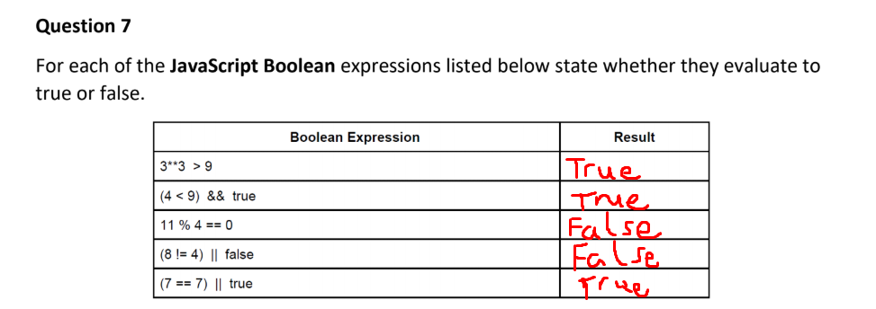

**8.** A digital camera needs a secondary storage in case the internal storage fills up while it is being used so there’s another place that the photos and videos can be stored as the primary storage in a camera is very small.

**(b)** 10

**(c) i → Kilobytes**

**ii → Megabytes**

**iii → Bytyes**

**9. A Syntax error** is when the program is not written properly so there will be an error in the code and it will not work meanwhile a **logic error** is when the program runs but doesn’t do what you want it to do so it needs to be fixed accordingly.

**10**. 